Department of Defense

DoD
Federal Employees Health Benefits Program
(FEHBP)

Demonstration Project

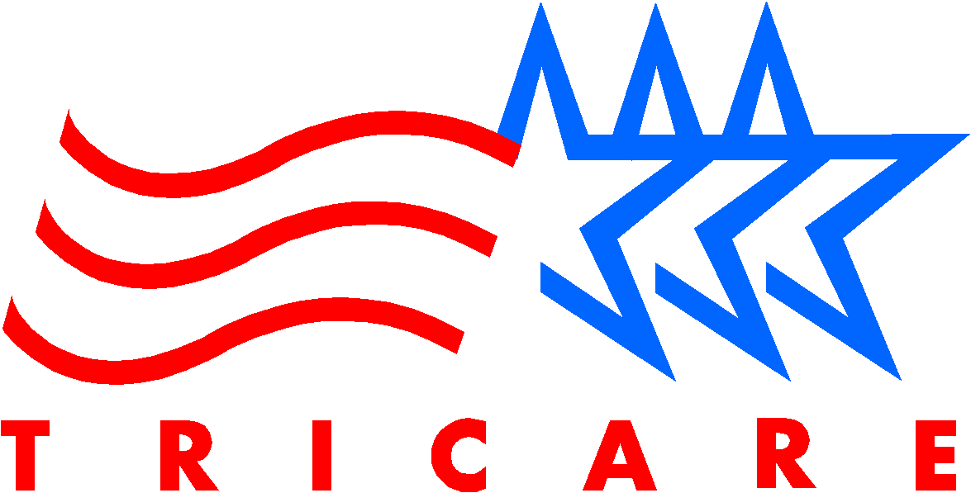

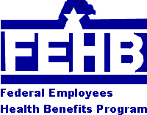
Department of Defense
TRICARE Management Activity
c/o Iowa Foundation for Medical Care
6000 Westown Parkway, Suite 350E
West Des Moines, IA 50266-7771

What happens if I am dissatisfied with the health plan I chose?

You can only change plans during the annual Open Season each fall. You can disenroll at any time, and again use Military Health System services. But if you disenroll, you can’t reenroll in the demonstration project at a later date.

How do I get information about the DoD/FEHBP Demonstration Project for participating FEHBP plans in my area?

- Visit DoD’s web site at:
www.tricare.osd.mil/fehbp, or the OPM web site at www.opm.gov/insure.
- Beginning September 7, 1999, you can call toll free, DoD’s Information Processing Center at 1-877-DOD-FEHB (1-877-363-3342).
- On October 30, 1999, you can get information about participating FEHB plans by calling toll free, DoD’s Information Processing Center at 1-877-DOD-FEHB (1-877-363-3342).

WHEN ENROLLING IN AN FEHB PLAN – CONSIDER THE FOLLOWING:

BENEFITS:
The benefits offered by each plan differ. Carefully choose a plan that offers the services that meet your health care needs. For example, not all plans cover chiropractic care and if chiropractic care is important to you, consider choosing a plan with chiropractic benefits.

COVERAGE:
You can choose to enroll only yourself, or yourself and eligible family members.

COST:
The cost of premiums, copayments, coinsurance, and deductibles will be different for each plan. Check the Guide, plan brochures and the web sites.

The government contributes toward the cost of the premium, lowering your out-of-pocket costs. The amount of DoD’s contribution can’t be more than the amount the government contributes for Federal civilian employees under the FEHBP. In October, 1999, just prior to Open Season, DoD will mail you a special guide for the DoD/FEHBP Demonstration Project which will list the information about participating plan benefits and premium costs.

Federal Employees Health Benefits Program (FEHBP) Demonstration Project

Beginning in November 1999, eligible military retirees and their families in eight geographic areas will have the opportunity to elect to participate in a demonstration project that will allow them to obtain their health insurance through the Federal Employees Health Benefits Program (FEHBP). The effective date of their enrollment will be January 1, 2000.

The Department of Defense (DoD) and the Office of Personnel Management (OPM) are opening enrollment in a DoD/FEHBP Demonstration Project to certain Medicare-eligible DoD beneficiaries, their family members, certain unremarried former spouses of military members, and eligible family members of deceased active or retired military members. The DoD/FEHBP Demonstration Project will provide access to enhanced medical care for up to 66,000 beneficiaries in eight designated geographical areas over a three-year period, beginning January 1, 2000.

What is FEHBP?

FEHBP is the Federal government’s health insurance program for civilian Federal employees, retirees, and their survivors.

FEHBP works just like any other employer-sponsored health insurance program; the employer, the Federal government, pays a percentage of the health care premium and the employee pays the rest. About two hundred fifty civilian health plans participate in FEHBP. Enrollees choose between three types of plans:

- Fee-for-Service (FFS) plans
- Health Maintenance Organizations (HMO)
- Point of Service (POS) plans

What is a FFS plan? What is an HMO? What is a POS?

- A FFS plan is a traditional type of insurance in which the health plan will either reimburse you or pay the medical provider directly for each covered medical expense after you receive the service.
- An HMO provides care through a network of physicians and hospitals in particular geographic or service areas.
- A POS is a product offered by an HMO or FFS plan that has features of both.

What is a “demonstration project”?
What is the DoD/FEHBP Demonstration Project?

A demonstration project is simply a trial period for a new program to see if it is cost-effective and meets the needs it was intended to serve.

The DoD/FEHBP Demonstration Project is a three-year test of a proven health care program for certain DoD beneficiaries. DoD chose eight locations in which to evaluate the program. During the test, we will evaluate the program to see if it meets its goal of providing access to affordable, high quality, comprehensive health care.

Who is eligible for the Demonstration?

Individuals are eligible for FEHBP if they reside in one of the eight DoD/FEHBP Demonstration Project areas and are a:
- Military Health System (MHS) beneficiary age 65 and over and eligible for Medicare Part A
- Family member of an eligible beneficiary*,
- Former spouse of a military service member who has not remarried*, or
- Family member of a deceased active or retired military service member*

* These individuals do not have to be Medicare
eligible to participate in the DoD/FEHBP
Demonstration Project.

Where are the eight locations for the demonstration project?

- Dover, DE Area
- Commonwealth of Puerto Rico
- Fort Knox, KY Area
- Greensboro/Winston Salem/High Point, NC Area
- Dallas, TX Area
- Humboldt County, CA Area
- Camp Pendleton, CA Area
- New Orleans, LA Area

How is the DoD/FEHBP Demonstration Project helpful for Medicare eligible retirees and other eligible beneficiaries?

The DoD/FEHBP Demonstration Project offers another health care option for certain DoD beneficiaries. If you are one, you should carefully evaluate the options available to you: The DoD/FEHBP Demonstration Project, TRICARE Senior Prime and Extra, space available MTF care, Medicare – to determine which program best meets your healthcare needs, including affordability.

How is enrolling in an FEHB plan beneficial to family members who are not Medicare-eligible?

Certain family members who are under age 65 are eligible for FEHBP:

- Certain family members of military retirees age 65 and over
- Certain former spouses of military service members who have not remarried
- Certain family members of deceased active or retired military members

These family members do not have to be eligible for Medicare to participate in the DoD/FEHBP Demonstration Project. Since many of these individuals do not have access to TRICARE Prime and Extra, an FEHB plan will give them the opportunity to have access to comprehensive health care.

How does the DoD/FEHBP Demonstration Project operate for DoD beneficiaries?

The DoD/FEHBP Demonstration Project works just like it does for Federal civilian employees. You can compare the participating FEHB plans in your area and choose a plan based on your individual needs. DoD will pay a portion of the cost of the health insurance premium.

While enrolled in FEHBP, neither you nor any family members in a self and family enrollment will be able to use Military Health System services, including TRICARE Senior Prime benefits, space available health care at military treatment facilities, or pharmacy services. Enrollees will get all of their covered healthcare benefits from their FEHBP plan.



